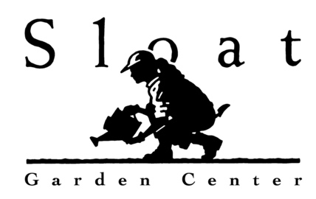
FALL IS FOR PLANTING
Sloat Garden Center Shopping list

- Plants - This is the add new plants to the garden
- Bags of compost, soil amendment, planting mix
- Bags of mulch
- Organic fertilizers
  - Dry fertilizers, such as EB Stone Organics, Down to Earth All Purpose, Jobe’s Organics Fertilizer Spikes
  - Earthworm Castings
  - Liquid fertilizers, such as EB Stone Organics Fish Emulsion with Kelp, Fox Farm Big Bloom, PNW Organics Fish On, Kelp Help & Oceans Gold

- Barriers
  - Row Cover
  - Bird Netting &/or Bird Scare Tape
  - Slug & Snail Copper tape
  - Gopher baskets
  - Insect Sticky Glue Barrier

- Deterrents
  - Bird Scare tape
  - Animal repellents

- Traps
  - Gopher traps

- Beneficial Insects
  - Beneficial nematodes

- Eco-friendly pesticides*:

  - Insecticidal soap
  - Neem oil
  - All Seasons Oil Spray
  - Horticultural Oil
  - Organicide 3-in-1
  - B.t.
  - Sluggo, Sluggo Maxx
  - Sluggo Plus
  - Garden Insect Control
  - Diatomaceous Earth
  - Captain Jack’s Dead Bug Brew
  - Take Down
  - Terro Liquid Ant Bait Station
  - Maggie’s Farm Ant Bait
  - Mosquito Bits & Dunks
  - Garden Fungicide
  - Copper Soap Fungicide
  - Complete Disease Control
  - Garden Sulfur

*Always read the label, understand how to use the pesticides, make sure the pest is listed, apply according to labels instructions and reapply accordingly, apply when beneficial insects & pollinators are not active or present

